**SSW 690B Weekly Status Update Due Monday by 11:59 pm**

# Team: Ayana Perry, Jinal Bangur, John Saterfiel, Tianhao Sun

Week Ending: Week 9 & 10 - 04-15-2019

INSTRUCTOR: DR. Richard Kempenski



## Project Status: (Green, yellow, red)

#### Good (More towards green ^_^)

**Team Status Summary: Where are we now?**

Currently we are setting up automation and manual test plan cases for Sprint 1 and 2. Now planning on for UAT testing for APIs. Also front end screens are ready with some tweaks here and there and are now planning for refinements in the application screens.

**Last week’s activities by team member: Ayana:**

1. What did I work on and what did I accomplish?

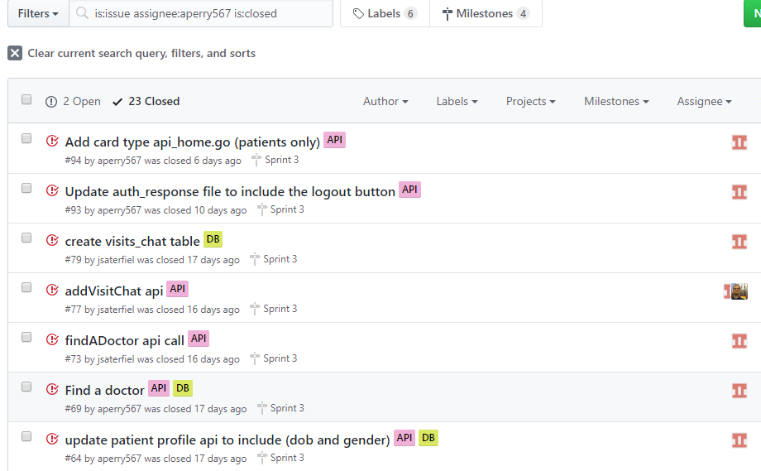

2.) Did I learn anything new this week (due to this project)?

* *Continuing to learn Go(lang) programming language.*
* *Continuing to learn and enhance my API development from scratch.*

***Jinal:***

1.) What did I work on?

* *Worked upon the test plan and completed it.*
* *Working on test cases for sprint 1 and 2*
* *Worked on homework assignment due on 04/09 and 04/15.*

2.) What did I accomplish?

* *I tried to accomplish my task well.*
* *Completed homework assignment due on 04/09 and 04/15 together combined.*

3.) Did I learn anything new this week? (Due to this project)

* *Trying to learn about different QA testing skills*

### John:

1. What did I work on and What did I accomplish?

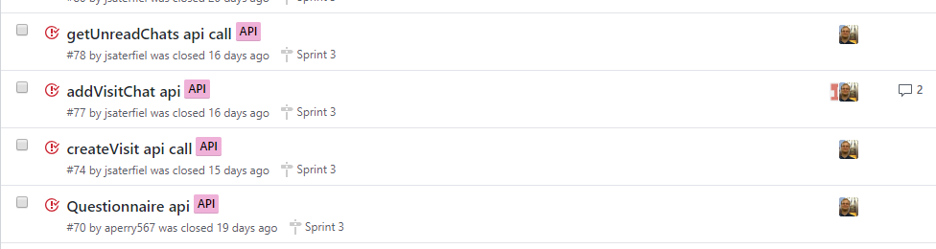

* *Also helping Tony with designing front end and fixing API issues as asked as well tweaking and fixing out screens here and there.*

2.) Did I learn anything new this week (due to this project)?

* *Enhanced go(lang) programming features.*
* *Also started my learning on unit testing for APIs*

### Tony:

1. What did I work on? And What did I accomplish?

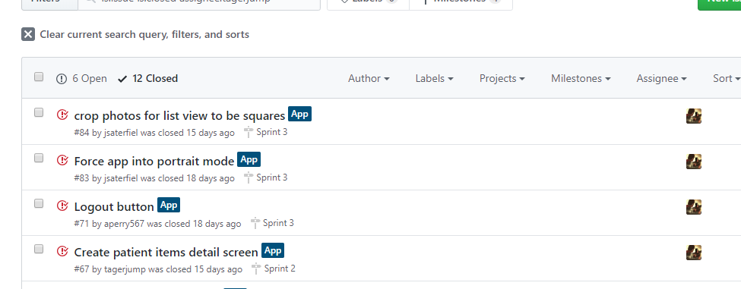

2.) Did I learn anything new this week (due to this project)?

* *Extended my learning on flutter for designing the screens*
* *Learning a lot more about android development designing using flutter*

### Issues, Risks, and Opportunities:

1.) What problems did you encounter and what impact might those have on meeting the project schedule?

* *The problems that were met during two weeks were a little bit of tweaking in designing of application and testing phase*
* *Had to make changes in screens which were decided to work as something different before. As well as had to do changes with API calls and designing screens and plans on adding payment system is a little problematic.*

### Action Items/Goals for next week: Team Goals for next week:

By next week the team goal is to complete Sprint 4 and UAT.

### Individual Goals: Ayana:

What do you plan to work on and accomplish in the next week?

* *Work as a team now for all the tweaks and work with Jinal for setting up test cases*

### Jinal:

What do you plan to work on and accomplish in the next week?

* *Work as a team now for all the tweaks and work with Ayana for setting up manual as well as automation test cases*

### John:

What do you plan to work on and accomplish in the next week?

* *Work as a team now for all the tweaks and work with Ayana for setting up automation test cases also help Tony set up front end screens*

### Tianhao:

What do you plan to work on and accomplish in the next week?

* *Work as a team now for all the tweaks and work with Jinal for setting up manual test plan cases and working on refining the application front end designing.*